Mongoid Integration Documentation

Version 1.0

Confidentiality and Non-discloser Notice
The information contained in this document is confidential and proprietary to RailsFactory [Reg: Sedin Technologies Pvt Ltd]. This information may not be disclosed, duplicated or used for any other purposes. The information contained in this document may not be released in whole or in part outside RailsFactory [Reg: Sedin Technologies Pvt Ltd] for any purpose without the express written permission of RailsFactory [Reg: Sedin Technologies Pvt Ltd].
© RailsFactory [Reg: Sedin Technologies Pvt Ltd] 2007

Document Information and Approvals

Version History
Version # | Date |  | Revised By | Reason for change
1.0 | 5 march 2012 |  | Chitrank samaiya

Document Approvals
Approver Name | Project Role |  | Signature/Electronic Approval | Date
Ashok Kumar | Tech Lead

STEP 1:
To create application with Mongo db you need to skip active record.
Type command rails new app_name -–skip-active-record
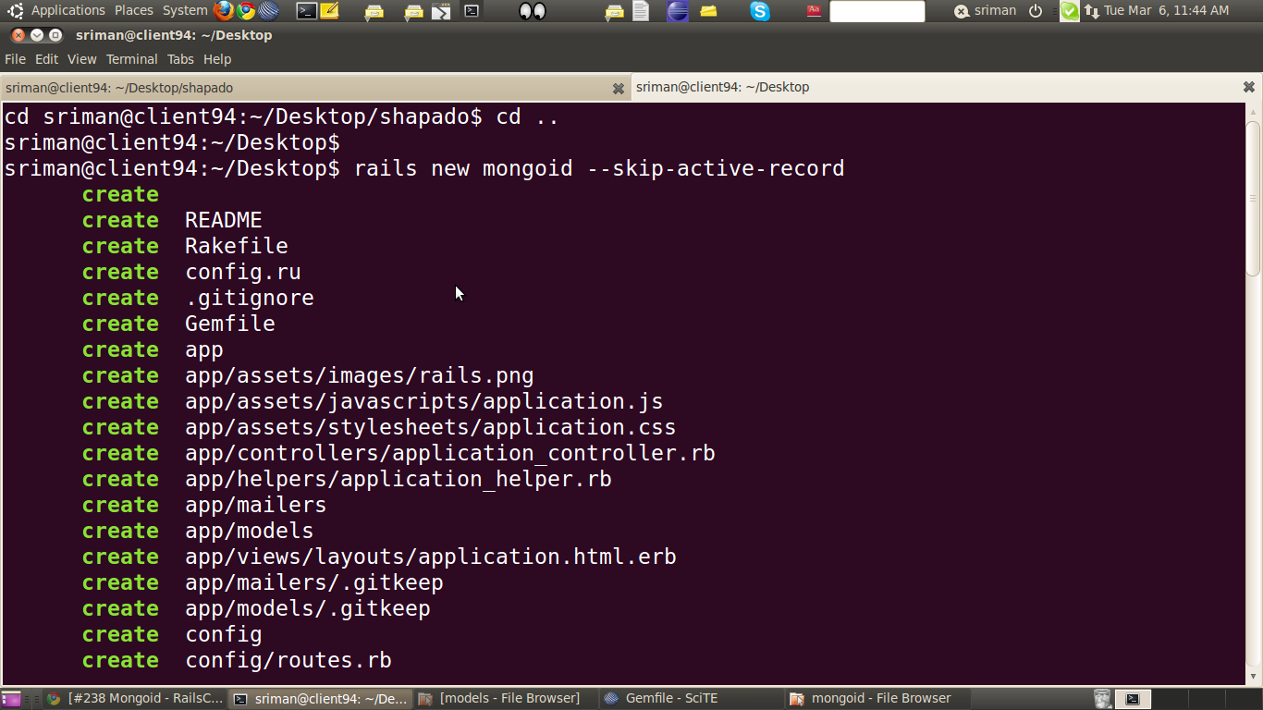
Mongo 1:-

STEP 2:
Before bundle install make sure that you have included following gems in your gemfile.
gem 'mongoid'
gem 'bson_ext'
run bundle intsall

Mongo 2:-

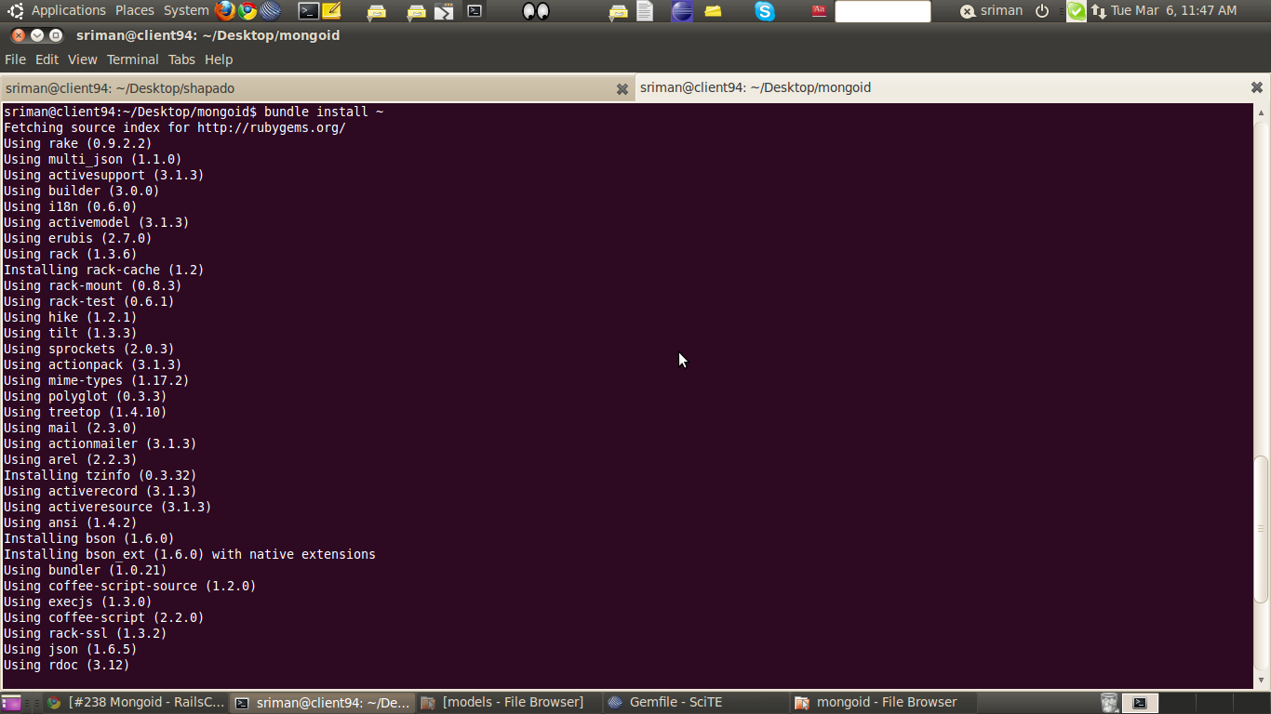
IF any problem occurs during bundle installation remember dependencies of mongoid should be of same version.Otherwise it will give error while installing bundle.

Mongo 3:-
Now you can see that dependencies of gem 'mongoid' are of same version in snapshot.
gem 'mongo' '1.6'
gem 'bson' '1.6'
gem 'bson_ext' '1.6'

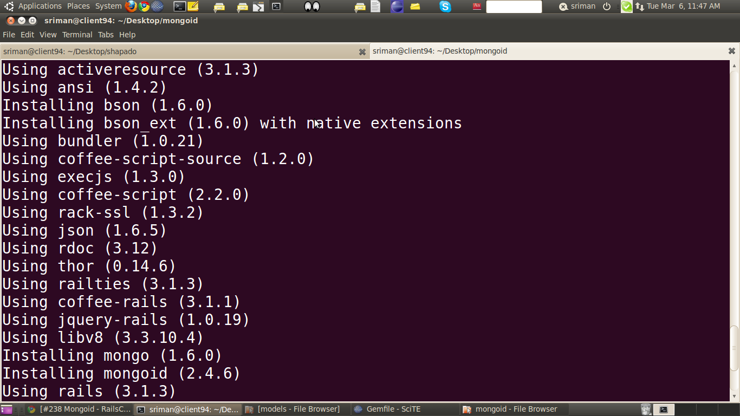
STEP 3:
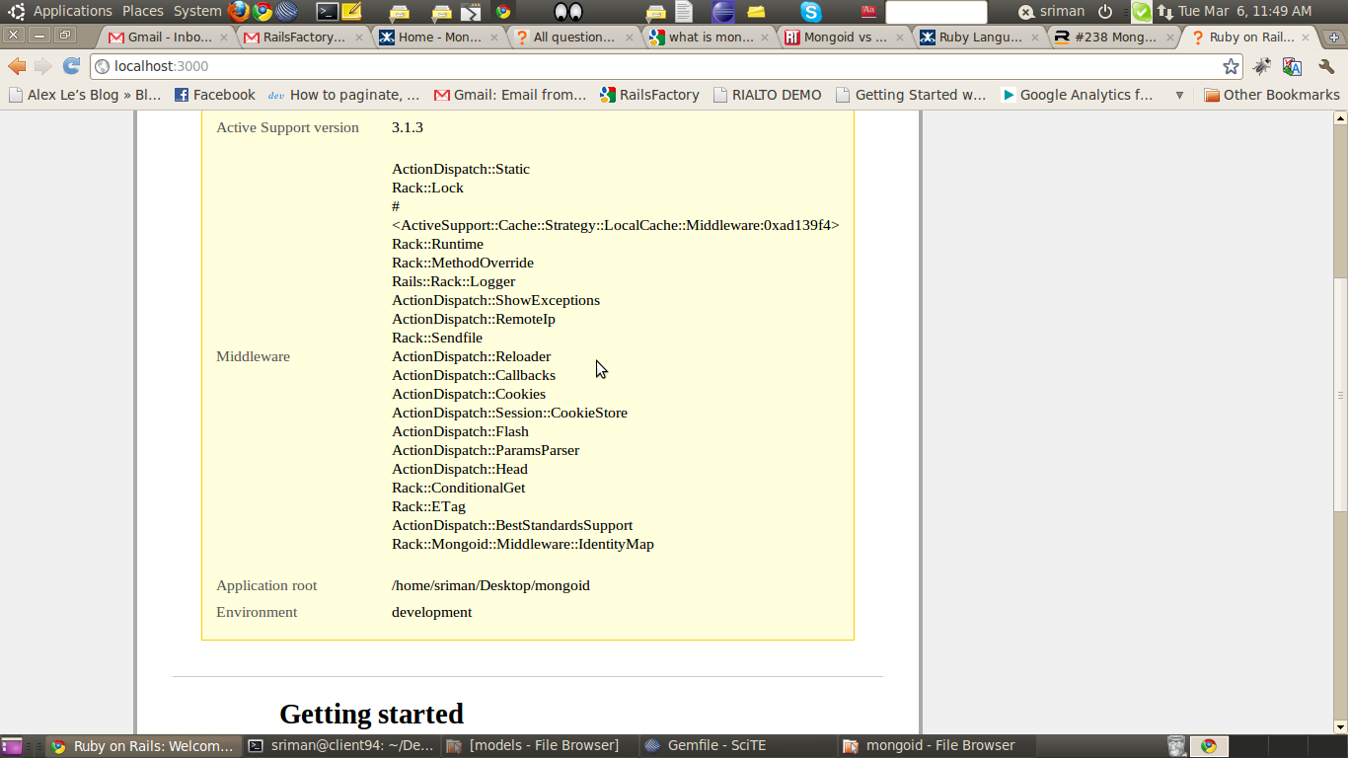
Now run the server check whether connection established with mongoid.
Mongo 4:-

Mongo 5:-
Now let's check rails server
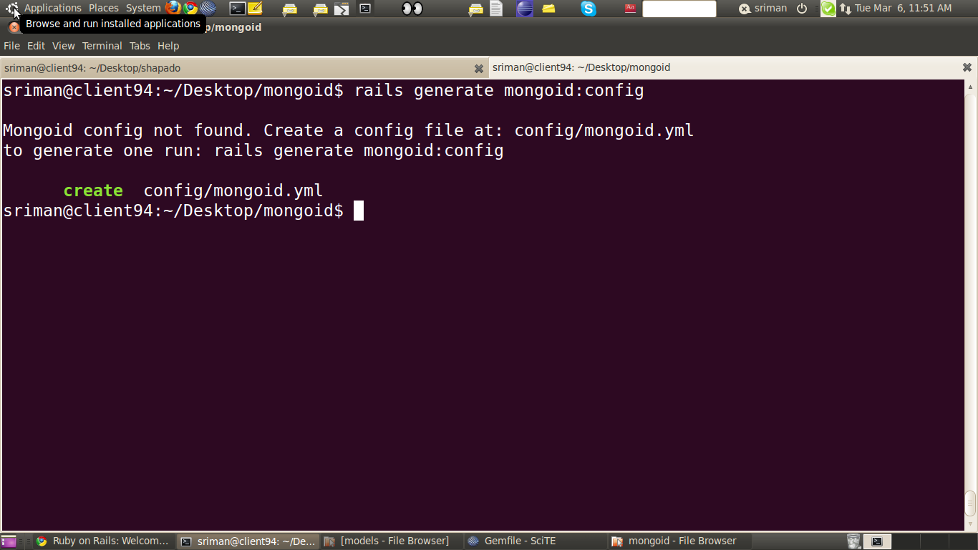
Mongoid.yml is not found.
STEP 4:
Let's create mongoid.yml file
rails g mongoid:config

Mongo 6:-
Mongo 7:-
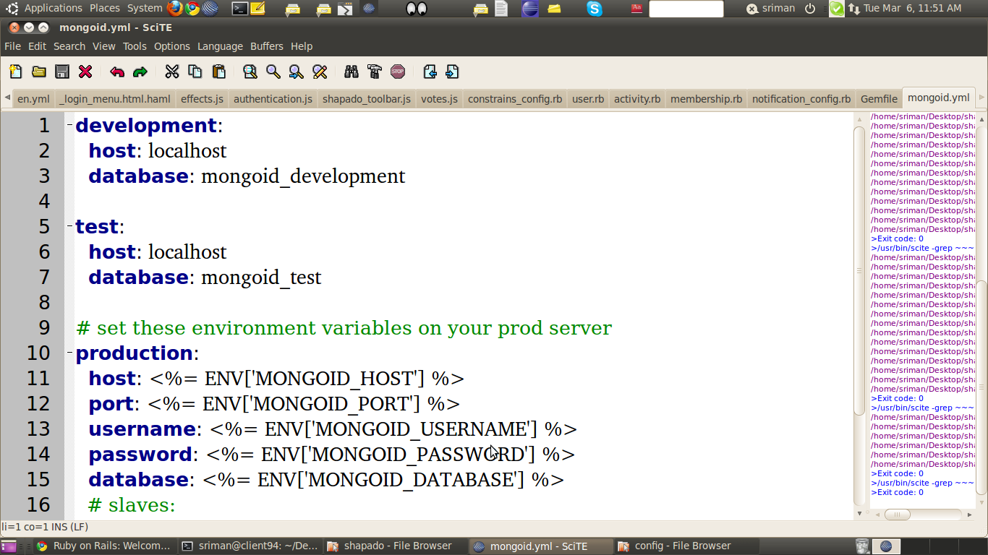
Mongo 8:-
Type localhost in url you will find given below
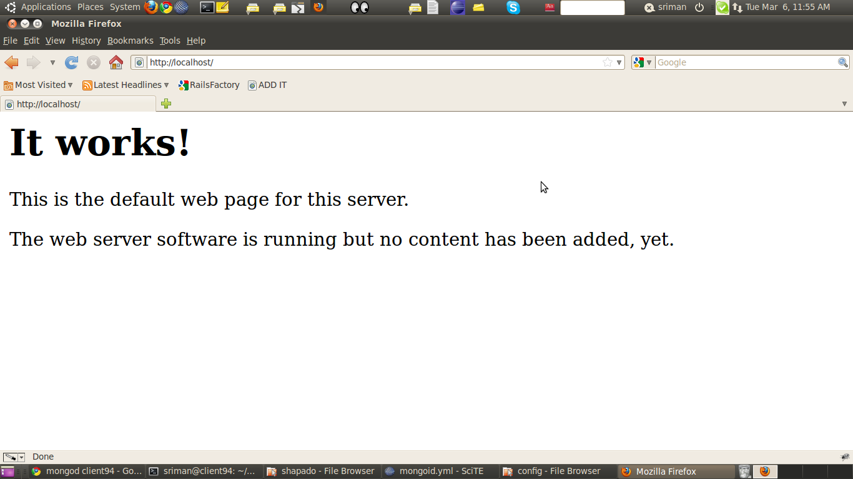
STEP 5:
Let's generate scaffold,here we dont need to mention skip active record though it is already mentioned.
Type command rails g scaffold article name:string content:text
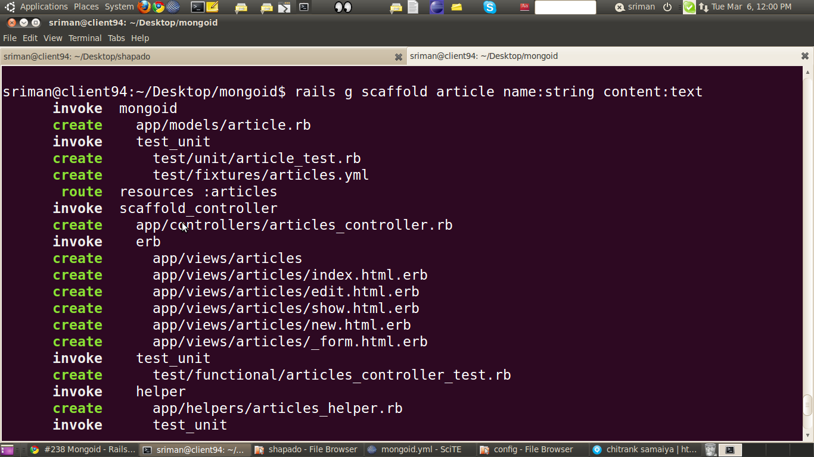
Mongo 9:-

When you will check your model you will find instead of
class Article<ActiveRecord::Base
end
class Article
include Mongoid::Document
end
Now instead of generating migration we will write fields in model itself.
class Article
include Mongoid::Document
field :name,:type => String
end
No need of migration file in mongo db.
Mongo 10:-
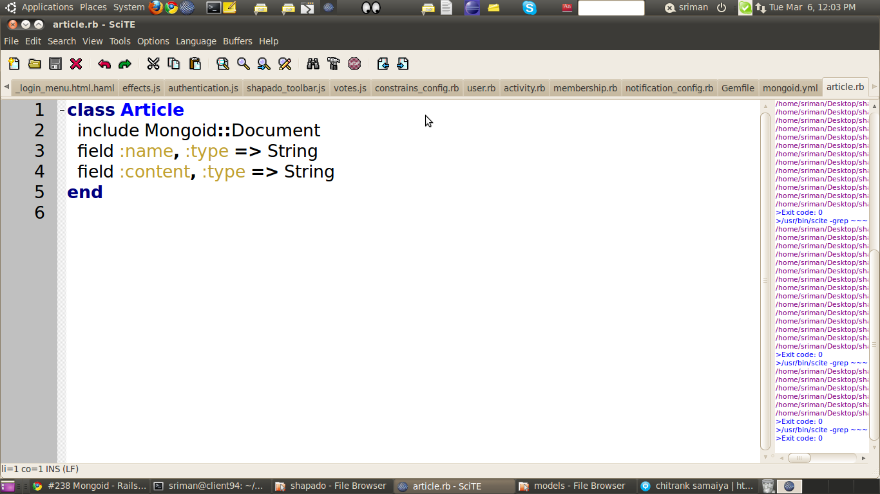

STEP 6:
Now run your server rails s
Mongo 11:-
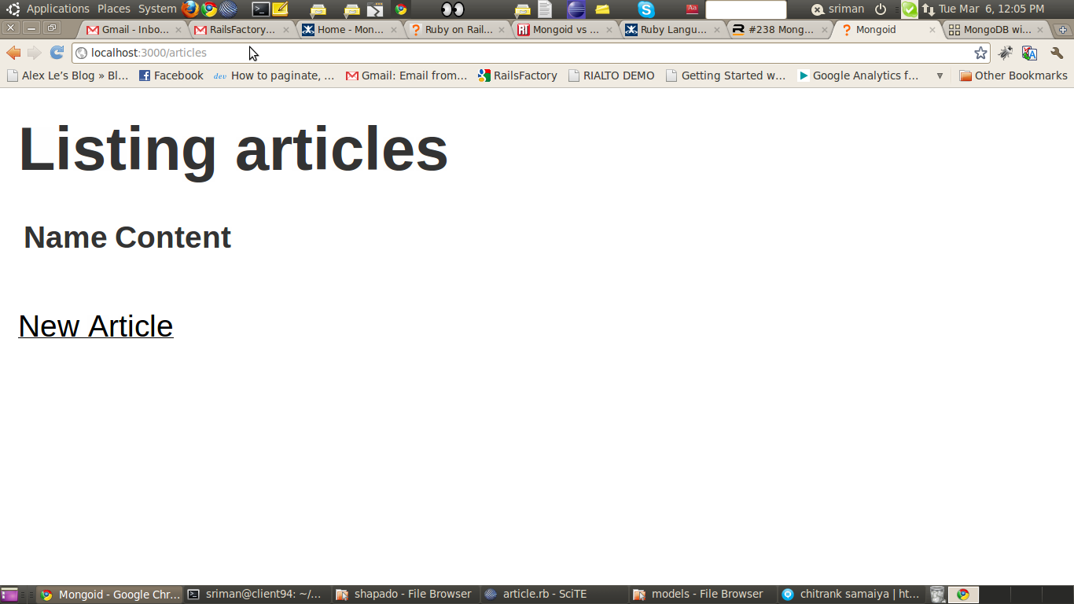
so your application is working.
STEP 7:
Validation and Association
Validation is same as it was in ActiveRecord but Associations is slightly different.Some new association are introduced.
embeds_many and embedded_in,embeds_one and embedded_in,references_many and referenced_in,references_one and referenced_in and associations used in active record.
Mongo 12:-

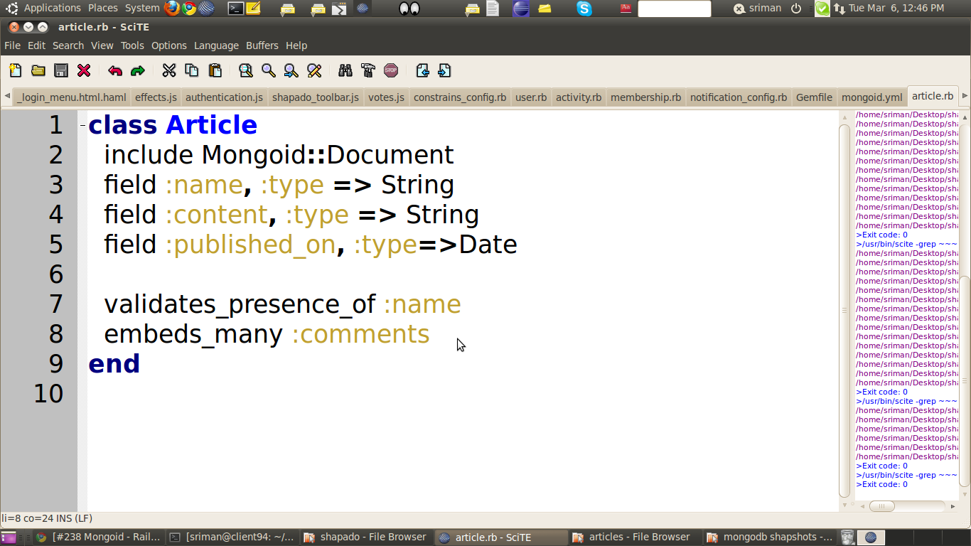
Mongo 13:-
